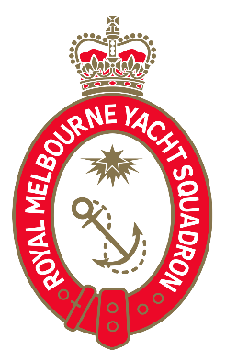

RMYS - Refund Policy

Unless otherwise specified by the Centre if an individual cancels their participation in a Course/Event, then the refund policy is set out below:
In every circumstance where a refund is requested, the first option is to transfer the participant to another applicable Course/Event. Where this is not possible, the following conditions apply:
- Notice period of Cancellation –
  - Less than 7 days prior to the Course/Event - No Refund
  - More than 7 and less than 14 days prior to the Course/Event - 50% Refund (less any transaction fees)
  - More than 14 days prior to the Course/Event - 100% Refund (less any transaction fees)
- Cancellation due to illness, injury or death:
If a participant is unable to participate in the Course/Event and can produce appropriate evidence, the fee will be fully refunded (less any transaction fee applied by the merchant).
- Event cancellation:
If the Event is cancelled by the event organiser, the fee will be fully refunded.
- Force Majeure:
If a Course/Event is cancelled due a reason outside the control of the organiser, a refund may be provided at the discretion of the Course/Event organiser.

