Reciprocal Club Information – February 2019
Royal Danish Yacht Club (Kongelig Dansk YachtKlub)

Reciprocal arrangements with Royal Danish Yacht Club have now been finalised by RMYS member Dr Peter Coulter, proper name Kongelig Dansk Yachtklub.

Website www.kdy.dk.
Facebook https://www.facebook.com/kongeligdanskyachtklub
You Tube https://www.youtube.com/channel/UCtpeu7g4TUBr40Z_aW_Yzbw
The link above to the KDY website is in Danish. To translate to english all you need to do if click on the Union Jack icon and you should get a ‘Translate’ pop up. Click on this pop and all pages will be translated to English.

Burgee

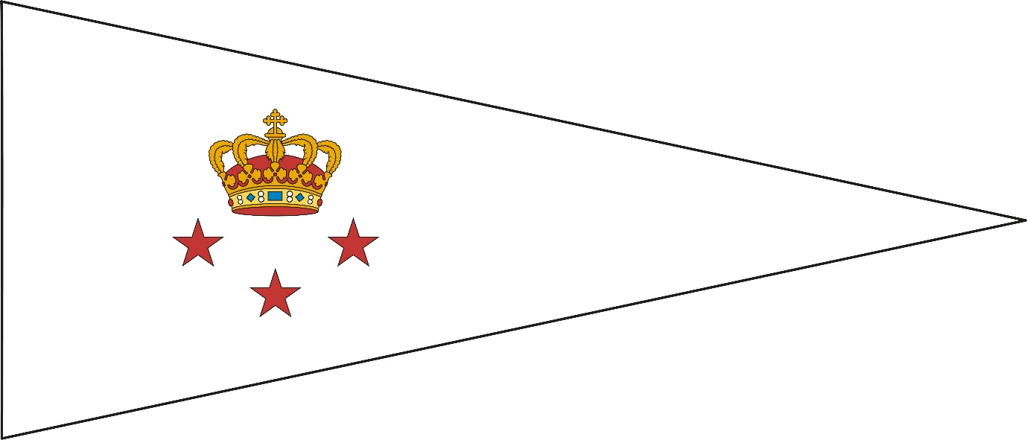

Here are some other thoughts and some information from the exchanges setting up the agreement, all in random order:-

- Crown Princess Mary (ex Tasmania) may well be seen there with Crown Prince Frederik. Both are honorary members and Frederik is patron – and is well known to have a sailing interest (as a result of which he met Mary from Tasmania.)
- Google maps will show location of Tuborg Havnepark 15 (KDY main address) in relation to Copenhagen CBD.
- KDY offers accommodation (limited) to reciprocal club members at same rate as members, c.f. Royal Thames rate for members is less than for reciprocals. Because limited advised to book ahead.
- KDY offers marina berthing for anyone from RMYS doughty enough to sail there. (We offer this in return but with a free period to make up for not being able to reciprocate their accommodation offer.)
- KDY has restaurants run by contractors as we do.
- KDY has a second location at Skovshoved Harbour further north of Copenhagen and a third at Rungsted Harbour more north again. (Both to be found on Google maps.) Unsure of facilities there but, for fans of “Out of Africa” and/or “Babette’s Feast”, the Karen Blixen Museum is in Rungsted.

